Ambient Systems: BoM and Specifications

Component Name | Part Number | Manufacturer | Description | Picture | Unit Price | Supplier | Quantity | Total
Board and microcontroller | Arduino Uno Rev3 SMD -- A000066 | Arduino | Board with processor and attachment ports | 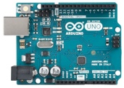 | $29.86 | RS-Online | 2 | $59.72
Temperature Sensor | MAX31889ALT+ | Maxim Integrated | Board Mount Temperature Sensors 0.1 degrees C accuracy, 1-Wire Temperature Sensor | 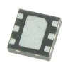 | $4.40 | Mouser | 2 | $8.80
Relative Humidity Sensor | SHT31-DIS-F2.5kS | Sensirion | Board Mount Humidity Sensors RH/ T Sensor | 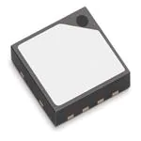 | $9.11 | Mouser | 2 | $18.22
CO2 Sensor | T6713-6H | Amphenol Advanced Sensors | Air Quality Sensors CO2 [Team member] for AAS-AQS-UNO | 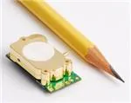 | $122.54 | Mouser | 2 | $245.08
Light Sensor | TSL2561T ams | ams | TSL2561T ams, Ambient Light Sensor Unit Surface Mount 6-Pin TMB | 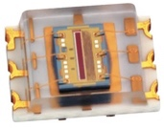 | $4.41 | RS-Online | 2 | $8.82
Transceiver | LR1110IMLTRT | Semtech | RF Transceiver LONG RANGE WI-FI LOC LORA TRANSCEIVER | 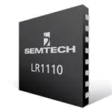 | $14.93 | Mouser | 2 | $29.86
ADCs | AD7795BRUZ | Analog Devices | Analog Devices AD7795BRUZ, 16-Bit Serial ADC Differential Input, 24-Pin TSSOP | 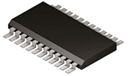 | $16.02 | RS-Online | 8 | $128.16
Device enclosure | NSYTBP342912T | Schneider Electric | Plastic Enclosure, [Team member], Multipurpose, Polycarbonate, 341 mm, 291 mm, 128 mm, IP66 | 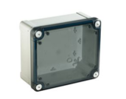 | $106.51 | Element 14 | 2 | $213.02
Total |  |  |  |  |  |  |  | $720  for 2 sensors

